[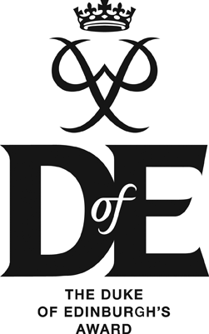](http://upload.wikimedia.org/wikipedia/commons/9/91/DofE-Logo-2008.gif)Durham Johnston

DUKE OF EDINBURGH (BRONZE) AWARD

PARTICIPANT APPLICATION FORM

**Name…………………………………………………………………………………..**

# Form……………………………………………………………………………………

**Gender………………………………………………………………………………...**

**Date of Birth…………………………………………………………………………**

Please indicate in the space below why you are interested in joining the Duke of Edinburgh (Bronze) Award and why you think you make a suitable candidate

Please outline any current involvement that you have with community and volunteering schemes / projects:

# 

Please outline any current or past experience you have of walking and camping:

List up to 4 friends that you would like to be placed in a group with (please note that this cannot be guaranteed)

1.

2.

3.

4.

**THANK YOU FOR YOUR APPLICATION – A LIST OF SUCCESSFUL APPLICANTS WILL BE PUT INTO FORM REGISTERS & ON THE D of E NOTICE BOARD.**